Rohan Radadiya (100704614), Walid Ayub (100695612)

Data Structures Final Project (Finger Tree)

Mr. Anwar

SOFE 2715U-001

CRN: 73375

Approach Of The Project:

The majority of the project was conducted from each of the group members’ houses. Frequent calls were done in order to proceed into the project and have updates often to see how it is going. After receiving the main topic, weekly meetings and conferences were done between each group member to share ideas and opinions for the final project. The entire project consisted of two different classes, which were in sense combined into one entire project of code. After the coding part of the project, comments were added in order to understand what each important line of code in the project did and what its purpose was in the class. After slight research about what a finger tree was, the project was able to move on because of coming up with some of the general ideas.

Explaining The Code:

To begin, the class was called “fingerTree:. That was the main topic of the project topic, so it made the most sense to just decide on choosing that as the class name. A finger tree is a functional data structure that can be used to efficiently implement other functional data structures. Also, this "summary" data stored in the internal nodes can be used to provide the functionality of data structures other than just the trees themselves.

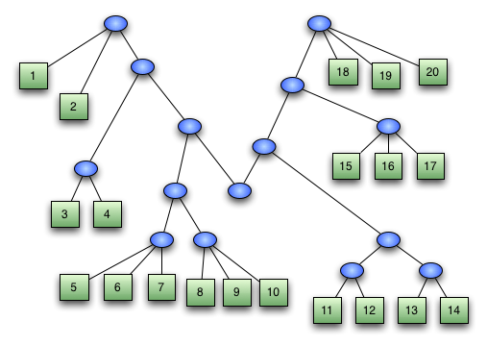

Above is an example of a finger tree. It is mostly seen as one giant tree with various branches, and there is data stored on each of the branches. They are all connected in all sorts of different ways, and because of that, the data is also interconnected all together. The entire program we made was also based on a similar type of scheme. The entire fingertree was connected to alternating data, and the entire program was based on remembering that the tree also needs to have the insertion and deletion properties.

How The Code Works:

The entire program has one class, abstract, named fingerTree. There were a number of different variables needed in order to construct the entire project. There were a number of methods needed in order for different segments of coding to work out as well. There are organized comments in lines in order for the reader to understand the grand scheme and how each line of coding works. All in all, the finger tree project was all about an interconnected object with different branches, each holding its own set of data.